Accessibility Perspectives and Minority Disability Achievement
By Keyonda Smith, PhD
Table of Contents
Digital Accessibility Challenges 2
1. Reliable Stable Internet 2
2. Device Usage 2
3. Socioeconomic Technology Gap 3
4. Systemic Barriers 3
Notable Disability Advocates 5
1. Fannie Lou Hamer 5
2. Donald Galloway 5
3. Brad Lomax 6
4. Claudia Gordon 6
5. Tatiana Lee 7
6. Dr. Feranmi Okanlami 7
7. Wesley Hamilton 7
8. Leon Ford 8
9. Andraéa LaVant 8
10. Haben Girma 8

The interests of programmers and designers are frequently prioritized above the perspective of the human or user when discussing disability and Accessibility. Efforts to ban teaching minority history in schools and the rising recognition of racism as a public health issue demonstrate a heightened need to heed the call to honor the achievements of minorities and leaders with achievements to celebrate their uniqueness. This lesson focuses on "Minority Disability and Accessibility," emphasizing excellent examples of minority leadership.
First, we will examine some of the unique challenges and obstacles many underrepresented groups face when accessing digital technologies. It has long been acknowledged that digital technology has the potential to assist those with varying abilities. Due to the length of time that these enhancements have been occurring, many people believe that accessibility is advancing simultaneously compared to digital device capabilities. A concerted and systematic effort is required to ensure that the promise of digital technology for inclusion is met. Yet, accessibility for individuals of various abilities is neither inevitable nor constant.
Minority Disability refers to a subgroup of individuals and their experiences that not only analyzes the theme of disability from a minority perspective but also demonstrates how the parallel minority identity may exist in the shadows of the minority community. Within the minority community, these individuals have the right to have their voices heard and experiences respected.

Digital Accessibility Challenges

Reliable Stable Internet
Due to the layered structure of the Internet and other digital technologies, higher-level protocols must have access to at least one lower-level protocol to operate. For instance, if the "sentences" protocol was unavailable, the "postcard" and "book" protocols could not be utilized for communication. Accessibility is directly affected because many Internet protocols are closed, meaning they are not publicly documented, encrypted, or protected by patents (Sawetrattanasatian et al., 2019). People with disabilities must depend on the generosity of those who manage these technologies to guarantee that their interfaces are accessible due to the absence of standards around proprietary protocols and file formats. This has proven deleterious even in societies with definite accessibility rules (Blanck & Sandler, 2000).

Device Usage
Consequentially, this area may appear as resulting from human ineptitude in the creation of technology. The current inability of technology to accommodate the many types of impairment impedes the broad adoption of digital accessibility solutions. Cognitive impairments have been more challenging to treat, as Kelly and colleagues (Kulkarni et al., 2017) and Lazar and colleagues (Kulkarni et al., 2016) describe (2015). Individuals with visual impairments may benefit from screen readers, while those with hearing impairments may gain from closed captioning. Special keyboards and other hardware devices may also be advantageous for those with physical impairments. However, in situations with cognitive impairments such as Down syndrome and Alzheimer's disease, technology is ineffectual and needs more development.

Additionally, technical breakthroughs have happened rapidly. This has led to the design and development of most assistive technologies being a "reactive process," such that technology has improved by the time new accommodations are included in existing products and services. This situation is aggravated by the fact that accessibility needs are often disregarded during product or service development (Dobransky & Hargittai, 2006). Cost is an additional barrier to the creation and use of digital accessibility. Thus, products and services created specifically for persons with disabilities are expensive to make and difficult for those with limited resources to purchase (Dobransky and Hargittai, 2006, Stienstra et al., 2007).

Socioeconomic Technology Gap
During the Coronavirus Pandemic of 2020–2022, the technological disparity between the haves and the have-nots will be starkly apparent. Throughout the outbreak, patients were authorized to participate in virtual sessions with clinicians using various telehealth videoconferencing technologies. According to several patients, a lack of facilities and inappropriate meeting space has resulted in "frustrating" delays and technical obstacles. Telemedicine technologies utilized for these encounters do not often provide captions. Auto-captioning is accessible on videoconferencing services like Skype, Google Meet, and Microsoft Teams, but not on Zoom due to its telemedicine-centric nature. This indicates that the relevant tools are already available. All these technologies provide HIPAA compliance as an option if used correctly.

Systemic Barriers
In the digital space, students' access issues are not being addressed. The Individuals with Disabilities Education Act (IDEA) ensures impaired students' access to higher education, but many have been left behind in a rush to transfer programs online. Worse, until recently, Education Secretary Betsy DeVos was undecided about whether to provide exemptions to schools that would have enabled them to avoid satisfying special education requirements. On May 11, 2020, four high school students, including a blind student from Pennsylvania, filed a civil rights case against the College Board for failing to make its Advanced Placement tests accessible via the National Federation of the Blind. Due to the broad spread of the coronavirus, the AP tests are now offered only in digital format, with Braille versions made available to individuals who need them. Complainants said that without the option for Braille and tactile diagrams, it is equivalent to asking a sighted person to turn off their screens, and The College Board should reinstate this service as it was before the outbreak.

Notable Disability Advocates
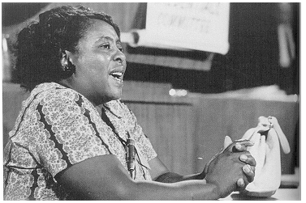
- Fannie Lou Hamer – 1917 saw the birth of Fannie Lou Hamer, the daughter of sharecroppers, in Mississippi. Her childhood affected her decision to become an activist. Hamer was born with a handicap caused by polio, and his health deteriorated in a Mississippi jail after he was cruelly abused. As a victim of forced sterilization, she also endured medical torture shared with hundreds of other Minority women of the era and untold numbers of disabled people throughout history. Hamer attended a civil rights conference organized by the Southern Christian Leadership Conference (SCLC) and the Student Nonviolent Coordinating Committee (SNCC) in the future (SNCC). She participated in the campaign for voting rights as a neighborhood organizer. She helped design Freedom Summer in 1964, co-founded the Mississippi Freedom Democratic Party (MFDP), and co-founded the National Women's Political Caucus in 1971. Her actions at the grassroots level altered the course of history in Mississippi, paving the way for hundreds of thousands of people to get the right to vote in her home state and throughout the nation. The AAPD also administers the Fannie Lou Hamer Leadership Program in her honor. This campaign aims to empower young people with disabilities from underrepresented groups (18–30 years old) to enhance minority voter engagement and turnout in the months before midterm elections.
Figure 1 Fannie Lou Hamer testifying at the Democratic Party convention in Atlantic City in 1964. (Image: Library of Congress)
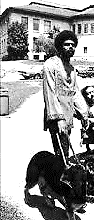
Figure 2 Donald Galloway in 1974

- Donald Galloway – Donald Galloway, born in Washington, D.C., in 1938, was blind as an adolescent because of an accident. Donald found pleasure in his injuries and used them as motivation to become a leader and advocate for persons with disabilities. He became a junior member of the National Federation of the Blind and the NAACP. Galloway, a graduate of the social work department at Berkeley, got affiliated with the Center for Independent Living. Galloway's leadership position at the Center for Independent Living chapter in Washington, D.C., is a direct outcome of his community involvement. His quest for legal representation in the Superior Court of the District of Columbia was a turning point in his activism. After receiving a jury summons, Galloway was prohibited from sitting on a jury due to his inability to see. Galloway responded by filing a lawsuit against the district; a court found in 1993 that dismissing a juror based on their disability was illegal. Through his activity, he could give the most disadvantaged segments of society a strong voice.

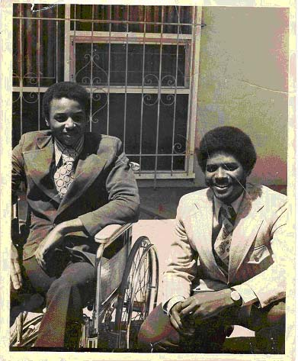
Figure 3 Brad and Glenn Lomax
- Brad Lomax – Brad Lomax was born in 1950 in Philadelphia and started using a wheelchair after being diagnosed with multiple sclerosis. He quickly realized that many constructions were inaccessible to him. He joined the Minority Panther Party in Washington, D.C., and helped organize the 1972 Africa Liberation Movement on the National Mall. 1973, when he had difficulty utilizing public transportation in Berkeley, California, he got involved in the local disability movement. He advocated for more help for disabled members of underrepresented groups, cooperating with the Minority Panther Party to assist in the Black communities of east Oakland. As a member of the activist group that successfully occupied the San Francisco Federal Building in 1977 to push the Section 504-Rehabilitation Act of 1973, he is regarded as a historical figure in the campaign. He took the effort to ensure that demonstrators had access to food, clothes, and shelter during the Section 504 sit-in. Participating in this attempt were the Minority Panthers and other grassroots organizations. His commitment to the disability rights movement laid the foundation for dramatic, long-lasting change.

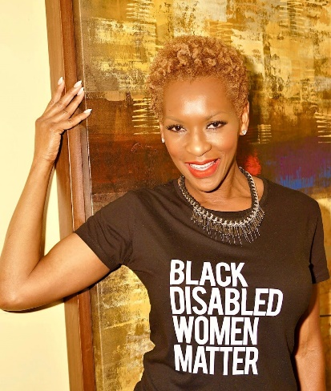
- Claudia Gordon - Born in Jamaica in 1972, Claudia Gordon is the first deaf person of color to get a J.D. in the United States. As a result of Gordon's hearing loss, she was taken out of school and only allowed to do housework. Deafness at such a young age was a significant source of discrimination for Gordon in her home in Jamaica. At age 11, she immigrated to the United States and enrolled at the Lexington school for the deaf in New York City. Claudia subsequently got a bachelor's degree in political science from Howard University and a doctorate in law from American University. After law school, she joined the Department of Homeland Security as a senior policy consultant. Her efforts to help the disabled in the aftermath of Hurricane Katrina pushed her to notoriety. The White House then requested her to assist the disability community as an advisor on public engagement. Gordon is a national pathfinder for people of color and folks with disabilities. In 2002, she was awarded the Paul G. Hearne Emerging Leader Award by the AAPD.
Figure 4 Claudia Gordon (National Disability Rights Network

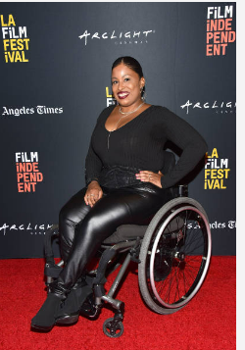
Figure 5 Tatiana Lee 2018 LA Film Festival (Getty Images)
- Tatiana Lee – Tatiana is an award-winning actress, model, and activist born with Spina Bifida. Growing up in Coatesville, Pennsylvania, Lee felt underrepresented in media and entertainment and began to utilize social media strategies. In vocal about disability visibility, Lee has leveraged social media to raise awareness and expand her platform for other disabled artists. She is the voice of the Accessible Hollywood brand; Lee's award-winning work can be seen in films such as Footloose, Jade, and Together & Better. Her modeling campaigns can be seen in ads at Target, Zappos, and more. Her commitment to creating a more inclusive Hollywood has made an opportunity for an awareness of other emerging disabled entertainers. She continues to speak, advise, consult, and educate others in film and media, including with companies like Netflix and The Walt Disney Company.

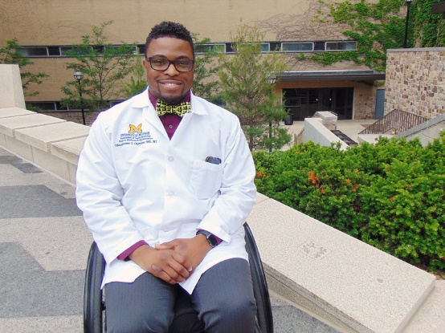
Figure 6 Dr. Feranmi Okanlami (Photo Source: Jina Sawani/University of Michigan)
- Dr. Feranmi Okanlami – Dr. Feranmi Okanlami, often known as "Dr. O," began her work as an advocate for individuals with disabilities by accident. During his fourth year as a surgical resident at Yale University, Dr. O's life drastically changed when he was paralyzed in a swimming accident. As an advocate for disability inclusion and especially diversity and inclusion in the medical sector, Dr. O has made it his mission to ensure that conversations about disability and diversity are essential to the experiences of doctors, medical students, and patients. His current job is as a professor of Michigan Medicine at the University of Michigan, where he often teaches medical students and professionals nationally.
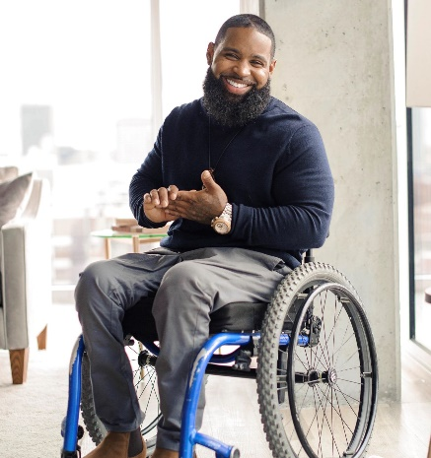
Figure 7 founder of the Disabled but Not Really Foundation
- Wesley Hamilton – Wesley Hamilton founded the non-profit organization "Disabled but Not Really" after becoming disabled when he survived a shooting that left him paralyzed from the waist down. Facing a long recovery journey, Hamilton decided to pivot and use his newly acquired disability status to make a difference for others. Now serving as an advocate in the disability community, Hamilton aims to ensure that individuals with disabilities access inclusive fitness training. In launching his accessible fitness program, he uses his platform to not only advocate for more inclusive fitness programs for wheelchair users. Still, he has also become a champion in speaking out on Minority disability representation and inclusion and ADA compliance.

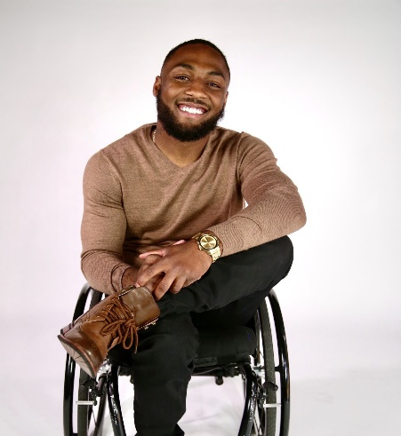
Figure 8 Leon Ford, Pi Capital
Leon Ford – Born in 1993 in Pittsburgh, Pennsylvania, during a routine traffic check, the police shot Leon Ford five times due to a terrible case of mistaken identification, leaving him paralyzed. An episode of misuse of police authority propelled Ford into the disability community at 19 years old. Leon authored Overcoming Adversity: Untold. He addresses conventional therapy, writing, reading, exercise, meditation, and introspection. 2023: The Phoenix Who Rises. Leon co-founded Starts with Us to eliminate conflict.

Leon teaches community and police culture. He creates PA force-use guidelines. Leon won Cannes 2019. Breaking Bread: A Discussion on Race in America (2021) received The Shorty Awards and features six strangers sharing a meal and having hard discussions to heal America.

Leon is part of the inaugural Aspen Institute Civil Society Fellowship, which educates community leaders, activists, and problem-solvers. He's a social impact entrepreneur in residence at Bronze Investments and co-founder of the Leon Ford Legacy Fund. Let's Reimagine. Pittsburgh's 40 Under 40.

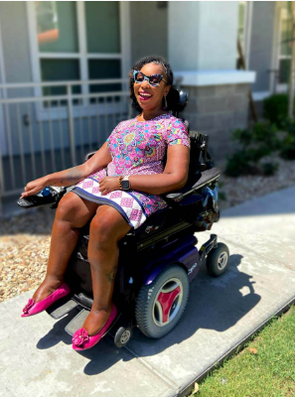
- Andraéa LaVant – Andraéa LaVant, from Louisville, Kentucky, was diagnosed with spinal muscular atrophy at age two. She is a master in the art of persuasion. Andrea is a cultural creator and impact generator who always looks magnificent. She founded LaVant Advice, which offers companies social impact communications and strategy advice so that they may fulfill the needs of individuals with disabilities more effectively and boldly. LaVant has been a prominent and vocal champion for individuals with disabilities for over 15 years. She was engaged in the production and promotion of the Oscar-nominated and highly praised documentary "Crip Camp" most recently. LaVant spent the first fifty years of her life "running away" from the label of disability; she is now at the forefront of efforts to normalize talks of disability in the media and eliminate the societal stigma that affects people of color with various abilities.
Figure 9 Andraéa LaVant (LaVant Consulting, Inc.)
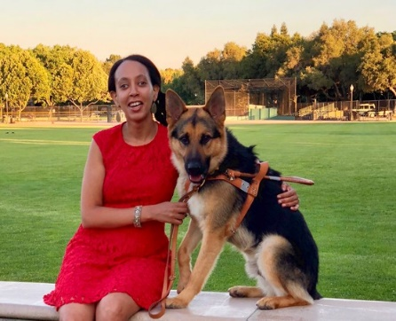
Figure 10 Haben Girma, Disability Justice Attorney
- Haben Girma – Born in Oakland, California, in 1988, Haben Girma is the first deaf-blind woman to graduate from Harvard Law School. Her journey to fighting for the full access and inclusion of individuals with disabilities began in her journey during her undergraduate studies, where she had to advocate for access to her school's cafeteria lunch menu. After graduating from Harvard Law School, she has written a memoir and consulted for globally recognized companies such as Apple, Microsoft, GE, SXSW, the New York Times, and more to improve their accessibility. She believes and often states that "disability is an opportunity to drive innovation." Girma uses her platform not only to advocate for accessibility but to create long-lasting solutions that benefit the disabled and those who do not identify as differently abled communities.

